Exp No: 12
EMBEDDED C PROGRAM TO MULTIPLY TWO 16-BIT BINARY NUMBERS
AIM:
To write an Embedded C program to multiply two 16-bit numbers using Keil software
SOFTWARE REQUIRED:
- Keil
PROGRAM :
#include <reg51.h>
void main()
{
while(1)
{
unsigned int num1, num2;
unsigned long int product;
num1 = 0x2222;
num2 = 0xBBBB;
product = (unsigned long int)num1 * num2;
P0 = product & 0xFF;
P1 = (product & 0xFF00) >> 8;
P2 = (product & 0xFF0000) >> 16;
P3 = (product & 0xFF000000) >> 24;
}
}
OUTPUT:
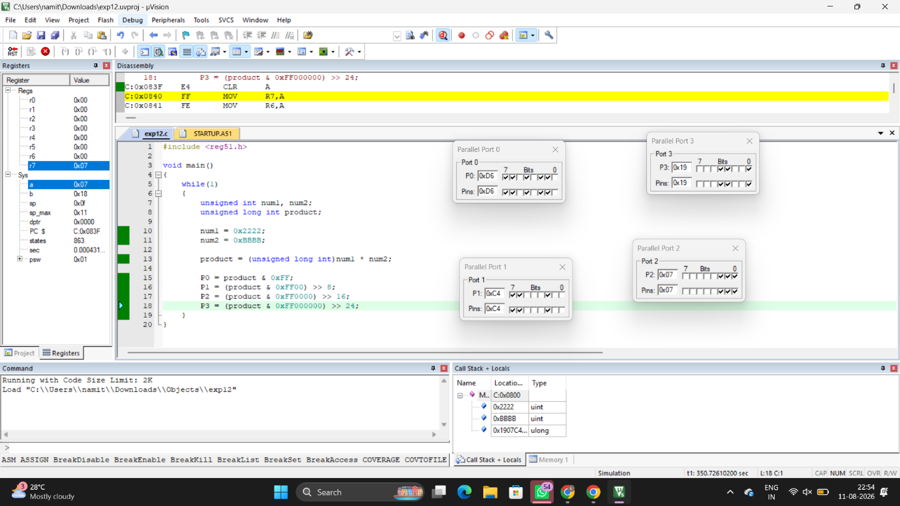

RESULT :
Thus the program has been successfully verified and executed.

